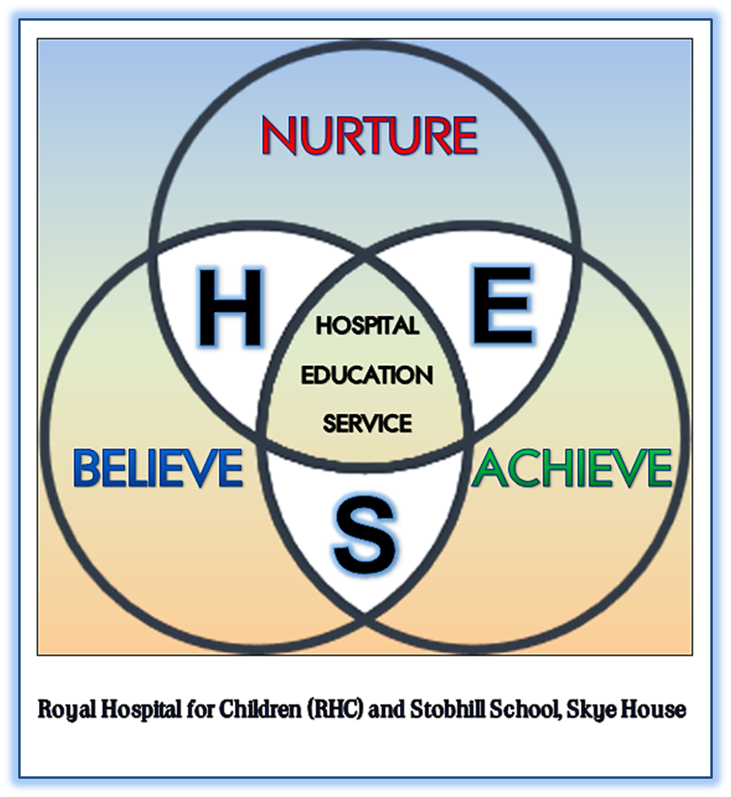
HOSPITAL EDUCATION SERVICE

MENTAL HEALTH (CARE AND TREATMENT) (SCOTLAND) ACT 2003

EMERGENCY DETENTION
An emergency detention certificate allows a person to be held in hospital for up to 72 hours while their condition is assessed.
- It can only take place when recommended by a doctor. Where possible, a mental health officer should also agree to it.
- You should not be given any treatment unless you agree to it, except for urgent treatment. The hospital must ensure an approved medical practitioner examines you as soon as possible.
- The hospital should give you information about your stay in hospital and explain your rights. They should also let you know how to get help from an independent advocate. There is no appeal against an emergency detention certificate.

SHORT-TERM DETENTION
Short-term detention should be the usual route into hospital under the law, as there are more safeguards for the individual.
- It can only take place if recommended by a psychiatrist and a mental health officer. Your named person should also be consulted.
- The hospital must appoint a psychiatrist as your responsible medical officer (RMO). Your RMO should examine you, talk to you to find out your wishes, read your advance statement if you have one, and decide if you need treatment.
- If your doctor feels that treatment is in your best interests, this can be given without your consent. Your RMO must follow the safeguards outlined in part 16 of the Mental Health Act when giving you treatment.
- The hospital should give you information about your stay in hospital and explain your rights. They should help you to get an independent advocate.
- You, or your named person, can appeal against your short-term detention to the Mental Health Tribunal.

COMPULSORY TREATMENT ORDERS
A compulsory treatment order (CTO) allows for a person to be treated for their mental illness.
- The CTO will set out a number of conditions that you will need to comply with. These conditions will depend on whether you have to stay in hospital or are in the community.
- Your mental health officer (MHO) will make an application for a CTO to the Mental Health Tribunal. The application must include two medical reports, an MHO report and a proposed care plan.
- You and your named person should be informed if an application for a CTO is to be made.
- The Tribunal decides whether a CTO is to be granted. The Tribunal is made up of three people - a lawyer, a psychiatrist, and another person with relevant skills and experience, e.g. a nurse, social worker, or someone with personal experience of mental disorder.
- You have the right to make your views heard by the Tribunal.
- The CTO can last up to six months. It can be extended for a further six months and then for periods of 12 months at a time.
- You can be given medical treatment while on a CTO if the Tribunal agree to it, or in an emergency. Your responsible medical officer (RMO) must follow the safeguards outlined in part 16 of the Mental Health Act when giving you treatment.
- You have the right to an independent advocate. This is someone who helps you say what you think about your treatment. Your MHO should let you know how to get help from an independent advocate.
- If a compulsory treatment order is made you, or your named person, can apply to the Tribunal for it to be removed once the order has been in force for three months. Your RMO should keep the need for the order under constant review, and can revoke it if you no longer need to be subject to the order.

PRINCIPLES OF THE ACT
The Mental Health Act principles were created to help people understand how the law should work in practice.
The principles were developed through consultation about what people felt was important to them, when they were being treated for a mental disorder. People who have received care and treatment and carers, as well as professionals, were involved in this consultation.

The ten principles of the act
- Take your past and present wishes into account.
- Make sure you get the information and support you need to take part in decisions.
- Take the views of your carer, named person, guardian, or welfare attorney into account.
- Look at the full range of options for your care.
- Give you treatment that provides maximum benefit.
- Take account of your background, beliefs, and abilities.
- Make sure that any restrictions on your freedom should be the 'minimum necessary in the circumstances'.
- Make sure that you are not being treated less favourably than other patients.
- Your carers' needs are taken into account and they get the information and support they need to help them care for you.
- Take special care of your welfare if you are under 18 years of age.
If you feel the principles are not being applied to your care and treatment, you should speak to your doctor (responsible medical officer). You may want to get some help from an independent advocacy service who can provide support, and help you get your views across.

INDEPENDENT ADVOCACY
Under the Mental Health (Scotland) Act, people with learning disabilities and people with a mental illness have a right to independent advocacy.
You do not have to be in hospital or under any mental health act in order to get this right to independent advocacy. This means that you should be able to have an independent advocate and/or join an advocacy group if you want to.

What is independent advocacy?
Independent advocacy helps you to make your voice stronger and to have as much control as possible over your life.
It is called independent because advocates and advocacy workers are separate from services. They do not work for hospitals, social work, or other services.

Why might I need independent advocacy?
Some people need support to speak up, to understand what is being said, and to make decisions. Many people find that when they feel ill or upset they are not as good at saying what they want and they need support to speak up.

When might I need independent advocacy?
There are some times when it is especially important for you to get advocacy support. These times may be when you are:
- In hospital
- Going to a Tribunal meeting
On an order which says that:
- you must stay in hospital
- you can only stay out of hospital on certain conditions
- you can be given treatment even if you do not want it

NAMED PERSONS
If you need treatment under the Mental Health (Care and Treatment) (Scotland) Act 2003 you can choose someone to help protect your interests.
This person is called a named person. Anyone aged 16 or over can choose a named person.
A child under the age of 16 cannot nominate a named person. The person with parental responsibilities for them is automatically their named person.

Who can I choose to be my named person?
- Your named person can make important decisions about your care if you are not able to decide yourself, so you should choose someone who knows you well and who you can trust.
- If you can choose your own named person it can be a relative or friend, but not somebody with a professional role in your care.
- You can say you don't want to have a named person.
You can have an independent advocate and a named person. Your advocate cannot be your named person because they have different jobs to do. Your independent advocate is someone who helps you say what you think about your treatment.
Your named person has a right to be consulted about some aspects of your care and treatment and can also make applications to the Mental Health Tribunal.
For more information see the Scottish Government's guidance on named persons*.
*This guidance on named persons is currently being updated with changes introduced by the Mental Health (Scotland) Act 2015, therefore some parts are out of date. Below is an overview of the main changes to named persons provisions made by the 2015 Act.

Changes to named persons provisions made by the Mental Health (Scotland) Act 2015
From 30 June 2017, changes are being phased in so that a person will not have a named person unless they nominate somebody to be their named person.
For a new named person nomination to be valid the nominated person has to consent, in writing, to be the named person, and that needs to be witnessed.
If you become subject to compulsion under the Mental Health Act now and you have not nominated a named person, you will not have a named person unless you do nominate somebody.
Some people were already subject an order under the Mental Health Act on 30 June 2017, and had a default named person. This would be their primary carer or nearest relative. If this applies to you, your default named person will continue to be your named person until any of the following happen:
- You nominate that person or someone else to be your named person
- You become informal (i.e. you are no longer subject to compulsion under the Mental Health Act)
- Your responsible medical officer reviews your Order for the first time after 30 September 2017
- If your default named person is still in place on 30 June 2018, their role stops then
The Scottish Government has suggested templates for named person nominations, declarations and consent on the Mental Health Act forms page.
Listed Initiators
The 2015 Act made provisions for other people to make applications or appeals to the Tribunal about your Mental Health Act Order if you do not have capacity to do so yourself, and you do not have a named person. These people are called 'listed initiators'.
Listed initiators include:
- Your nearest relative
- Your primary carer (if you have one)
- Your welfare guardian (if you have one)
- Your welfare attorney (if you have appointed a welfare attorney, and it is operational)
If you do NOT want your primary carer or nearest relative to act as a listed initiator for you, you can make a written declaration to say they cannot do this. To write this declaration you need to be capable of doing so, and it needs to be witnessed. The Scottish Government has provided a suggested template for this on the Mental Health Act forms page.

MENTAL HEALTH TRIBUNAL
The Tribunal is an independent organisation set up to make decisions on the compulsory care and treatment of people with mental disorders in Scotland.
The Tribunal has a President and 300 members around Scotland.
If you have a Tribunal meeting there will be a group of three people - a doctor (psychiatrist), a lawyer, and another person with relevant skills and experience, e.g. a nurse, social worker, or someone with personal experience of mental illness, learning disability, dementia or related conditions.
A Tribunal meeting is often called a 'hearing'. The Tribunal must hear and read all the information about you and your case. They then decide what to do about your care and treatment.

What does the Tribunal do?
The main role of the Tribunal is to consider and determine applications for compulsory treatment orders (CTOs) under the 2003 Act. It also considers appeals against compulsory measures such as short-term detention certificates and CTOs. The Tribunal also reviews every CTO once it has been in place for two years and every two years after that.

How do I contact the Tribunal?
You can write or phone the Tribunal office. You can ask your named person, independent advocate, or solicitor to help you to do this.
Mental Health Tribunal for Scotland
1st Floor Bothwell House
Hamilton Business Park, Caird Park
HAMILTON ML3 0QA
Mental Health Professionals: 01698 390 000
Enquiries from patients, carers, general public: 0800 345 70 60 (Freephone)
website: www.mhtscot.gov.uk

RIGHTS OF CARERS
The Mental Health (Scotland) Act 2003 says a carer is someone who gives you care and support when you need it.
Your carer could be:
- your husband/wife
- your partner
- a friend
- a relative
- a neighbour
You can have more than one carer. They can care for you and support you in different ways. For example, they can help with shopping, cooking and cleaning. They can listen to your problems and help you make decisions.
A carer is someone who helps you because they want to help you. It is not their job to do this. If someone helps you as part of their job they are not called carers. For example, a home help is not called a carer because it is their job.

Who is my primary carer?
Your primary carer is the person who gives you all, or most, of your care and support. If you have more than one carer, they must decide who the primary carer is. You can help to decide this. You can only have one primary carer.

What are my carers' rights?
When doctors and others decide about your care and treatment they should:
- find out what your carer thinks.
- think about your carer's rights.
- give your carer any information they need. They only do this if you agree.
- your carer can go to the Mental Health Tribunal and tell them about your care and treatment needs.

MENTAL HEALTH OFFICERS
A mental health officer is a social worker who has special training and experience in working with people who have a mental illness, learning disability, dementia or related condition.

When might I have a mental health officer?
If you become ill and lose the ability to make your own decisions, you can be given compulsory care and treatment. This only happens if it is necessary and if there is a risk to you or others.

What does my mental health officer do?
Your mental health officer:
- tells you about your rights.
- writes reports and care plans.
- agrees that you need to be examined by a doctor.
- asks for you to have a compulsory treatment order if you need this. This means you have treatment even if you do not want it.

Can I change my mental health officer?
Yes. If you cannot work with your mental health officer, your social work department helps to sort out the problem or chooses a new mental health officer for you.
You may want to change your mental health officer because you do not agree with their decisions. A new mental health officer may make the same decisions about your care and treatment.

SAFEGUARDED TREATMENTS
Certain treatments have special rules, known as safeguards.
You can be given medication without your consent in the first two months of your treatment.
Treatments with special safeguards from the start include:
- Artificial feeding
- Electroconvulsive therapy (ECT)
- Other treatments that act directly on your brain
- Medication where the purpose is to reduce sex drive
After two months, you can only continue to have medication if:
- you are capable of consenting and agree to take it, or
- a designated medical practitioner (DMP) decides that you should have the treatment.

What is a designated medical practitioner?
DMPs are experienced psychiatrists. When you need the safeguard of a DMP, your doctor will contact us and we'll ask a DMP to see you.
The DMP who comes to see you will work in a different hospital to the one you are in. The DMP will have specialist knowledge of the treatment that is being proposed. They have experience as NHS consultants and are asked to undertake independent opinions for the Commission.

What does the DMP do?
Your own doctor will put forward a plan for treating you. The DMP's job is to decide whether the treatment the doctor has put in this plan is in line with the law and is in your best interests. The DMP can only give an opinion on the specific medical treatment. The DMP cannot give a second opinion on your diagnosis or general treatment. Before making a decision, the DMP will:
- talk to you and listen to your views about your treatment;
- assess your mental state;
- look at your case notes;
- pay particular attention to an advance statement if you've made one;
- consult others (including your named person) about your care, if practical.

CRIMINAL PROCEDURE ACT
If the police believe a person has done something wrong, they may have to go to court.
There may be criminal proceedings. These are the steps the police and courts take to decide if a person is guilty or not guilty. These are some of the things that happen:
- The court can ask a doctor to examine you to find out about your mental disorder
- The doctor gives the court a report
- The report helps the court decide if you need treatment
- The court decides what to do about your case

