Mindfulness Matters
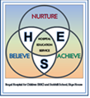
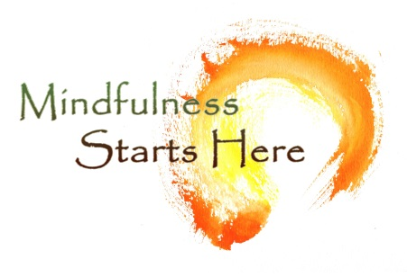
Welcome to issue 1 2019-20
Thought for the new session
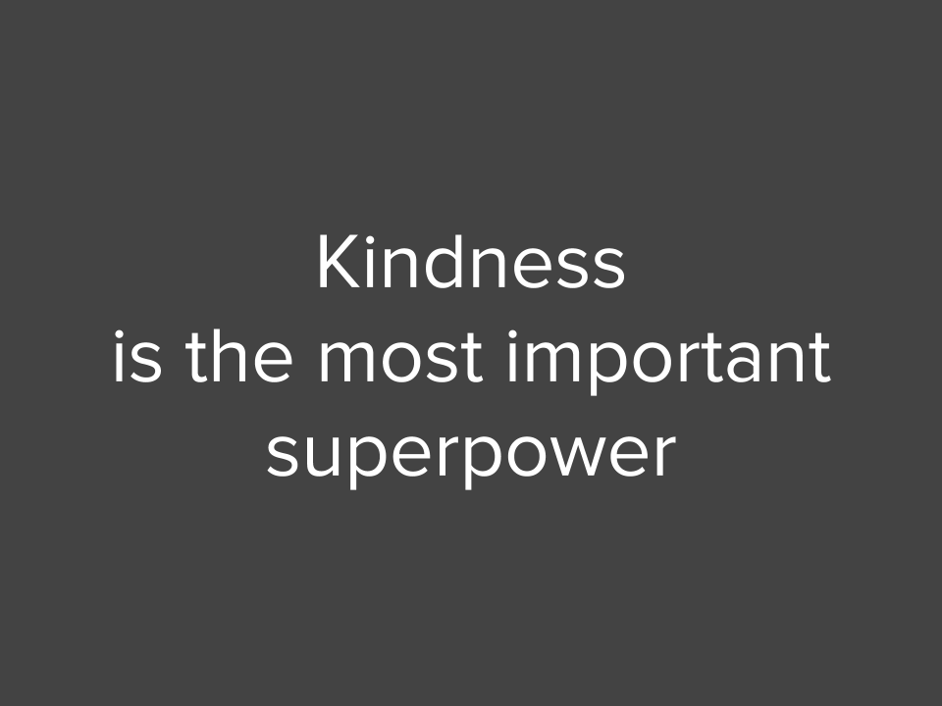

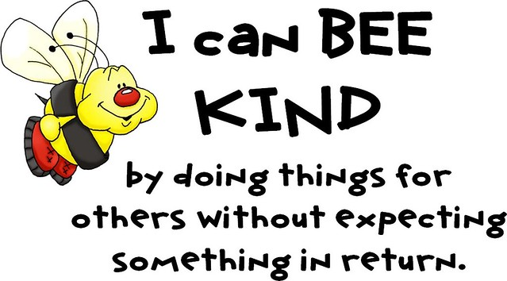

Listening to Radio 2 to Zoe Ball on the way to work,
I listened to an interview with Emily Coxhead who has produced a quarterly Newspaper called
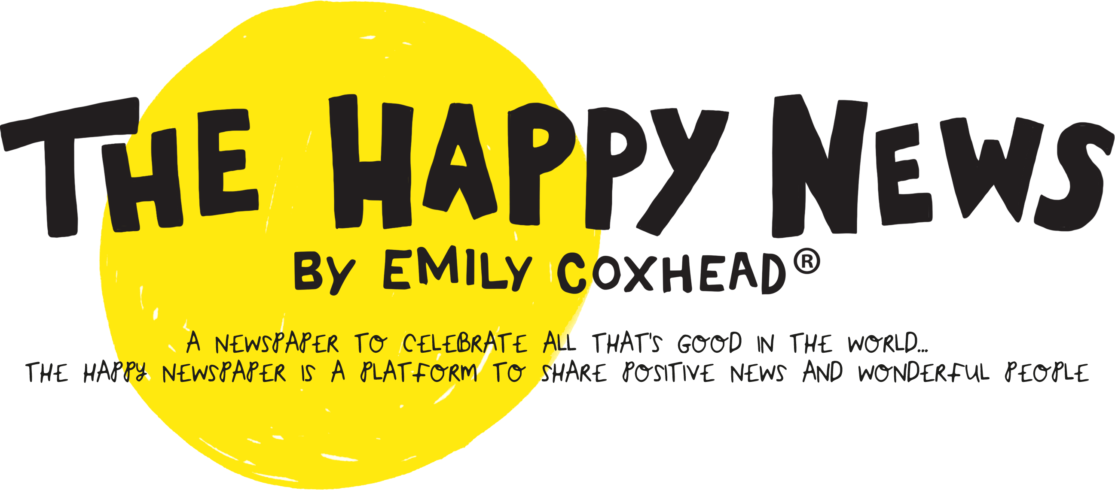

She says
“Every single day there are people helping others and doing incredible things in all corners of the planet and the majority of them aren't celebrated, but they deserve to be recognised.”
They are aiming to bring a refreshing twist on what is typically known as 'news', reporting on positive changes and truly inspiring people.

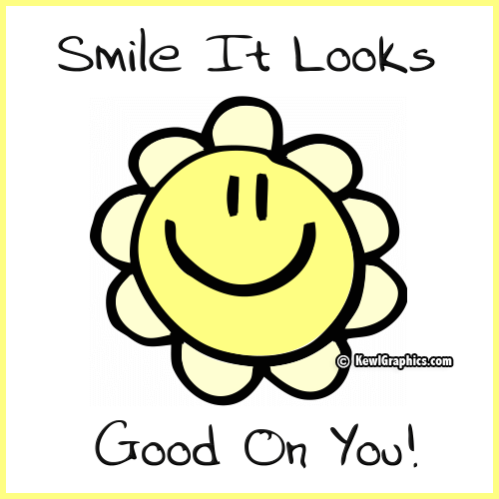

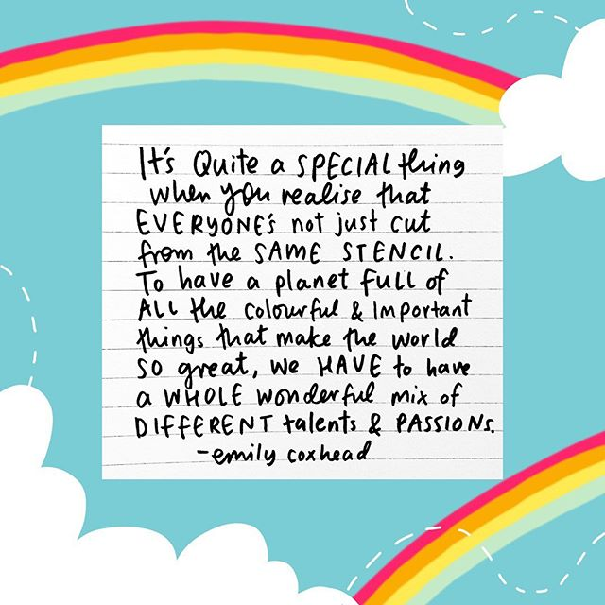

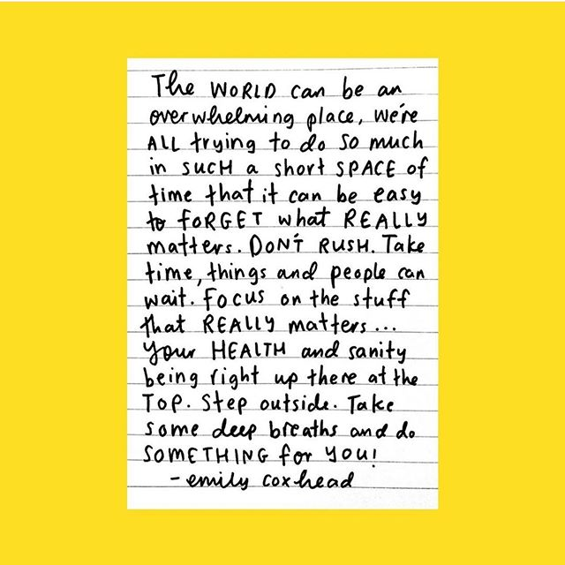

And a wee pic to finish
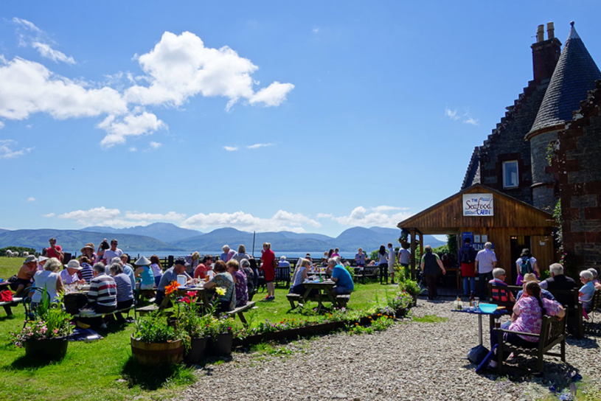

Monday night tea at Seafood Cabin Skipness ( on mainland overlooking Arran )
- well worth a visit!
Amazing collection of people Germans, Belgians, French, Japanese – not sure how they all found it!

August 2019

