Hospital Education Service
Who are we?

We provide education for young people from across Scotland who are unable to attend school due to significant health needs.
We provide suitable, flexible education appropriate to their needs.
We are employed by GCC Education Department.

Where does teaching happen at HES?

At RHC:
- There are classrooms in Ward 4 (Child Psychiatry Inpatient Unit) and Clinic 12
- Most teaching is on a 1:1 basis and takes place at the patient’s bedside in individual rooms
- At RHC, teaching times are flexible to meet the needs of individual learners throughout the hospital. There are strict infection control procedures which must be adhered to - these can affect whether or not pupils can be taught in small groups
At Stobhill School:
- There’s a number of well-resourced classrooms for various subjects
- Class sizes are small and with 1:1 support, students can study targeted materials for their age and stage
- At Stobhill School, our day is divided into 7 periods
What does teaching look like at HES?

Where appropriate, we support students to keep up-to-date with coursework and any other activities they would undertake in ideal circumstances at their base schools.

- Our curriculum is designed to meet individual pupil needs
- We teach SQA coursework where possible and appropriate; we provide study support for subjects not currently taught at Stobhill School
- We may provide teaching up to Higher and Advanced Higher in subjects such as English and Maths
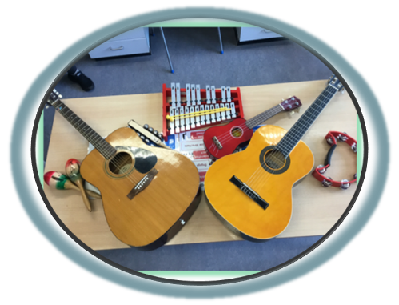
- We offer a range of Wider Achievement courses including Employability and Wellbeing, Duke of Edinburgh

How we meet your child’s needs:

We work with the following agencies/stakeholders:
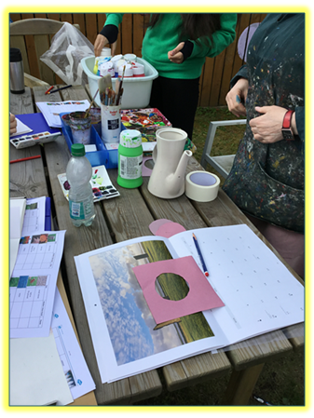
- Parents/Carers
- Schools (Pastoral Care)
- Consultants
- Psychologists
- Nurses
- Dieticians
- Occupational Therapists
- Speech and Language Therapists
- Social Workers
- Family Therapists
- Any other appropriate agencies

How to contact us:

You’re welcome to visit us at Hospital Education Service and meet our staff. If this is something you’d like to do or if you have any questions please don’t hesitate to contact the HES Leadership Team at:

Tel: (0141) 232 6630
E-mail: office@hes.glasgow.sch.uk

Anne Gillespie
(Lead for ILS and Hospital Education Service) Hospital Education Service Stobhill School 133 Balornock Road Glasgow G21 3UW
VISION
Hospital Education Service will work in partnership with medical staff, schools and parents to support the learning, health and wellbeing of each young person while they are in hospital.

VALUES
- Nurture
- Believe
- Achieve

AIMS
HES will:
- Provide high-quality teaching to raise attainment and achievement
- Meet each pupil’s needs regardless of any barriers to their education
- Build positive partnerships with our Multi-Disciplinary Team, parents and schools
HOSPITAL EDUCATION SERVICE (HES)
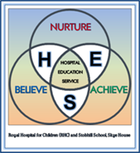

Royal Hospital for Children (RHC) and Stobhill School, Skye House

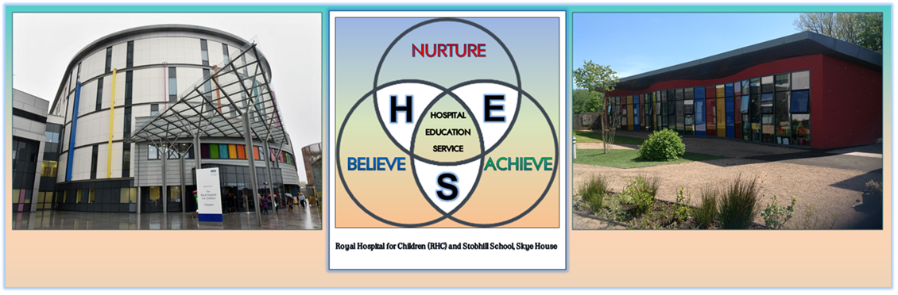
INFORMATION FOR PARENTS 2025-26


Hospital Education Service is part of Glasgow Virtual School

